| ABOUT OUR WELLIB

*Innovation for a better life*

| **WHO WE ARE** | **OUR VALUES** | **OUR ORGANIZATION** |
| --- | --- | --- |

**WHO WE ARE**

**Since 2023, a digital library for all. Read well, live better.**

*Welcome to Wellib!*

We are a hub of knowledge, creativity, and community, dedicated to providing an enriching experience for all of our visitors. With a vast collection of books, magazines, and digital resources, we strive to cater to the diverse interests and passions of our patrons. Whether you are a voracious reader, a student seeking information, or simply looking for a tranquil space to escape and explore, our library is the perfect place for you. Our dedicated team of librarians and staff are here to assist you in your quest for knowledge, guiding you through our extensive collection, and helping you navigate the ever-evolving world of information and technology. Join us in this wonderful journey of discovery, inspiration, and lifelong learning at our library – where stories come alive, imaginations soar, and connections are made. Explore, engage, and experience the magic of reading and knowledge at your fingertips. Welcome to a world of endless possibilities at our library!

**OUR VALUES**

**OUR PURPOSE**

A digital library serving and connecting with all readers.

**OUR VISION**

**“**Of the people, by the people, for the people**”**

**OUR MISSION**

The mission of Wellib is to provide easy and open access to a wide range of digital resources, promoting inclusivity by removing barriers to access. We aim to organize, preserve, and disseminate knowledge worldwide, democratizing information for the advancement of society. At our core, our mission is to promote learning, connecting, sharing, and innovation for a better life.

**OUR VALUES**

***W****ealth of knowledge for the community.*

Having access to a variety of educational resources and expert guidance, the community is blessed with a wealth of knowledge that empowers individuals to grow and thrive.

#### **E**ncouraging social innovation.

Empowering individuals with the tools, resources, and support they need, encouraging social innovation creates an environment where new ideas flourish and positive change can be realized.

***L****istening and sympathy.*

Listening attentively and showing genuine sympathy, providing not just knowledge but also emotional support to those seeking solace or guidance.

***L****iberal Library.*

Promoting diverse perspectives and embracing a wide range of ideas, fostering an environment where critical thinking and open dialogue thrive.

***I****nterconnected**Library.*

Empowering patrons to explore a vast digital landscape and foster collaboration, transforming our interconnected library into a hub of innovation and connectivity.

***B****etterment all the time.*

Striving to enhance its offerings, services, and facilities, ensuring that patrons have access to the best resources and experiences to support their lifelong learning journey.

**OUR SOCIAL COMMITMENT TO COMMON KNOWLEDGE**

Our social commitment is to promote access to knowledge and foster a sense of community. We strive to make knowledge accessible to all, regardless of barriers or limitations. Together, we can shape a more enlightened and connected society.

**OUR ORGANIZATION**

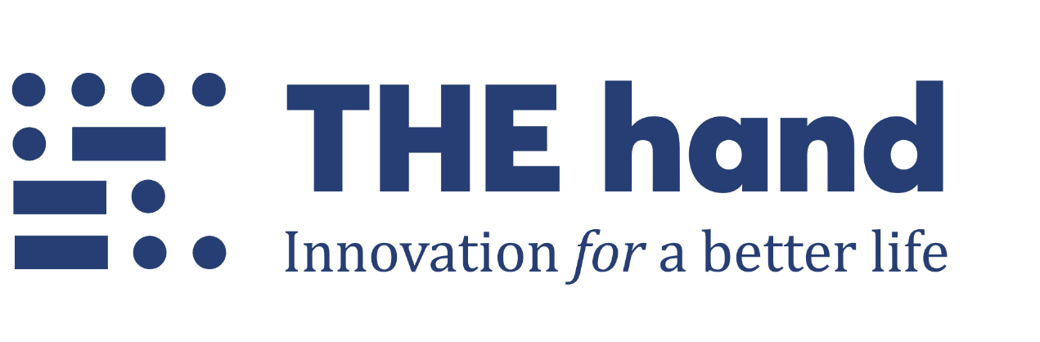

In its early days, The Hand laid the foundation and provided the driving force behind the establishment of the Wellib, setting it on a path of growth and accomplishment.

While in the Interim period, the operation of our Wellib will be overseen by an executive board consisting of members from The Hand.

In the future, the organizational plans include the formation of a board of directors composed of members who will be elected from the sponsoring organizations.

The Wellib is committed to staying ahead of the curve and embracing opportunities to better serve its community, fostering a culture of lifelong learning, innovation, and connection in the years to come.